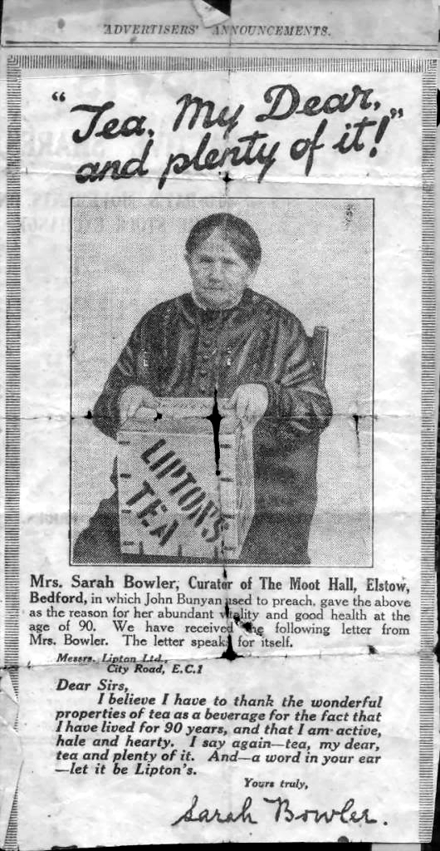

This is, probably, the best known member of the Bowler family.

She was born in 1837 as Sarah Mayhew, married Charles Bowler in 1856, and died in 1929, aged 92.

In 1927, Sarah wrote to the Lipton Tea company, saying that she thought tea was what had enabled her to reach the age of 90 and still be ‘active, hale and hearty. She was, at this time, curator of Moot Hall, which was probably then only being used for storage.

In response to Sarah’s letter, Sir Thomas Lipton visited Elstow and, outside Moot Hall, presented her with a box of tea. They were photographed and the pictures ere used by Liptons for publicity purposes.

The box she is pictured with here looks somewhat bigger than the one she was given at Moot Hall, so may be a display one – or perhaps they gave her a second box as thanks for letting the company use her image and story?

There are photographs of her and Sir Thomas stored on the Elstow picture archive - on this page; https://elstow.weebly.com/old-elstow.html
Also, on the 1920s page of the May festival albums, there are photos of Sarah at the 1926 and 1927 events.

To see Sarah’s position in the Bowler – Berwick – Roberts family tree, go to page 2 of this document.
Minnie
Theodora May
1891

Arthur Charles
1890

Jeremiah Bowler = M = Mary Knight
B1773 d1830
The Elstow Bowler – Berwick – Roberts Family

John William
1894

Mary
1832

Arthur
Charles
1923-36

Constance
1916

Rita
Marjorie
1909

Frederick
Theodora
1906

Bertha = M 1938 = Albert Curtis
Ada
1915-62

Freda = M1939 = George Roberts
Elizabeth
1930

Arthur John Berwick = M1906 = Annie
1886-1972 1886-1966

Susan B1798
Mary B1800

Lizzie 1803-4

Pheobe 1805
Richard = m1831 = Sarah Whittamore
1810 -1888 b1812
Pheobe 1863

William
1858-9

Ellen
1856

Emma
1848

Sarah
1847

Richard
1844

Thomas
1843

Maria
1840
?
John
1838

James
1836

?
1831

Caroline
Susanna
1834-34

Charles === M 1856 === Sarah Mayhew
1835-1918 1837-1929
John
1856

Elizabeth
1859

Arthur = M? = Emily Cole = M = Minnie Golding 1861-

Martha
1867

Jane = M 1894 = Charles Cirket
1859

Sarah Anne
1872

Christopher E
1877

Bertha M
1884-1974?

