The Hillersdens – A story of wealth, power, early deaths and a mansion.

After the surrender of Elstow Abbey in 1539, the manor of Elstow and all its lands and buildings were granted to Sir Humphrey Radclyffe.

In 1613, a barrister named Thomas Hillersdon (of Membland in Devon) and his wife Joan acquired Wakes Manor in Eversholt. They settled in Little Park, Ampthill and had two sons and two daughters.

The eldest, Thomas II, married Elizabeth Harding in Chalgrove in 1598. Thomas II decided to add to the family estate and, in 1616, purchased (for £700) the Elstow Abbey estate from Sir Thomas Radclyffe and John Cheke, together with much of the rest of Elstow and Cardington, together with properties in Kempston, Wilstead and Bedford.
Owning so much property elevated Thomas to the gentry and he was knighted by James I at Theobalds Park, Cheshunt, Herts. Thomas also claimed to be lord of the manor of Hockliffe.

Thomas II left numerous charitable bequests, as well as money for the restoration or ‘re-framing’ of old houses in Elstow and for the demolition of others. He also ‘desired’ that the rest of the manor of Elstow be purchased for his son (Thomas III). This was accomplished in 1631.

Thomas Hillersden III had been born in 1610 and baptised in Ampthill. Like his father, he sought to increase the family’s fortune and estate. This included purchasing a house in Caxton, Hunt for his sister Elizabeth. In 1628, he married Margaret, daughter of Sir William Lytton, in Knebworth. Thomas III then began converting the north-western section of Elstow Abbey’s former 14th century cloisters into a mansion. Unfortunately, like so many of the Hillersdens, Thomas III died young - in August 1632, aged only 22, leaving his wife and a two year old son - also called Thomas( IV) a bequest of £500 to ensure that the mansion project be completed.

The mansion was named “Elstow Place”. It was an impressive and beautiful building, with an elaborately carved stone entrance, thought to have been designed by Inago Jones. From this east-facing entrance, a wide driveway ran eastwards, linking the house to Elstow High Street. The contours of that drive can still be seen in the field between Elstow High Street and the Abbey site.

John Bunyan (1628-88) would, from early childhood, have seen “Elstow Place” every time he walked from his home, in Bunyan’s End (near Harrowden Lane) to Elstow. Compared to the lowly dwellings of the rest of Elstow, the Hillersdens’ mansion would have seemed like a palace to the young Bunyan. So it seems likely that, whilst “Houghton House” in Ampthill is often cited as the inspiration for ‘House Beautiful’, in Bunyan’s “The Pilgrim’s Progress”, he probably had “Elstow Place just as much in mind.

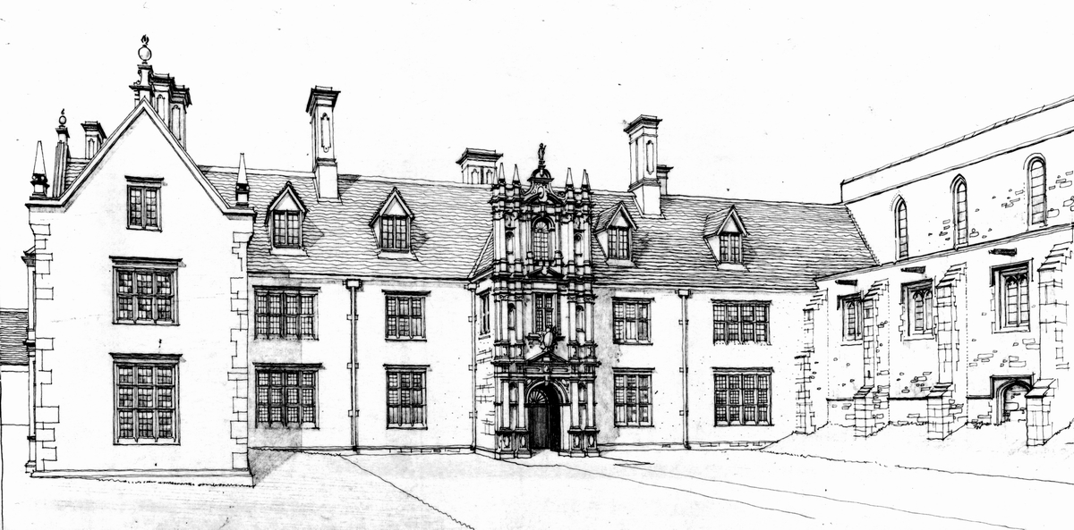 Architect Bernard West’s interpretation of how “Elstow Place” probably appeared.
There is also a model of the mansion, which can be viewed in Elstow’s Moot Hall.

There were three more generations of Thomas’s and both the fifth and sixth of them became members of parliament. But then, Thomas VI broke family tradition, by naming his oldest son ‘William’.

William followed other family traditions – like all the Thomas’s, he became a barrister and an MP (first for Bedford Borough, then for the County).
William named his son Thomas (VII) but that Thomas died even younger than his namesakes, aged only 12. There being no male heir to the family fortune, Thomas VII’s sister Elizabeth inherited and then married a relation, Dennis Farrer. Dennis died aged only 48 and in 1738, Elizabeth died, aged 33.
Their two sons, William and Thomas died in infancy, leaving the estate to the youngest son Dennis, born 1732. He lived longer than most of the male Hillersden, dying in 1787 aged 55.

Dennis was the last male of the family and his death resulted in the end of the Hillersden’s wealth. His four daughters, unable to finance the upkeep of the mansion, sold” Elstow Place” and the Abbey grounds to Samuel Whitbread of Southill. Over following years, lack of income forced them to sell the rest of the family’s estates to the Whitbreads.
By 1794, Elstow Place was no longer habitable and the Misses Hillersden were living in Elstow Lodge, just south of Elstow Brook, the mansion having been left to fall into ruin.

Those ruins are now a scheduled Ancient Monument. It is planned, when finances are secured, to use the remaining walls to form part of a new church hall. Thus the site has come full circle, back into church use.

For further information on the Hillersden family, go to Bedford.gov.uk/moothall & click on the “History and Archive” menu item, then scroll down the page to the ‘Hillersden’ links.
For pictures of the mansion/ its ruins, click on the link to ‘Elstow Photo Archive’.

Clive Arnold September 2015 clivearnold.weebly.com

