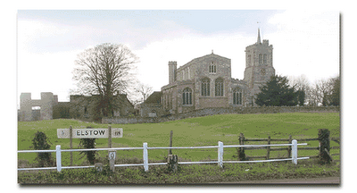
Maypole at Elstow 1957-1958
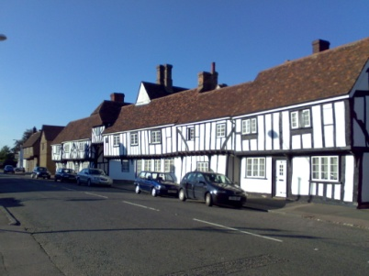
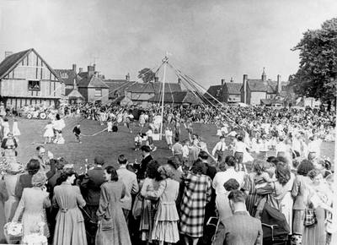

A row of cottages in Shakespeare style, overhanging upper rooms
Bunting clad. Union Jacks, jutting from windows that looked out
Across the village green, where soon would be the Maypole scene.

There Annie Berrick stood at her door, to welcome her friends
With her wrinkled smile. Down a step into her parlour, a cosy space,
Flowery curtains, cushions and antimacassars trimmed with lace.

Through in the next room such a spread of cakes, trifles, sandwiches
With home-made bread. In the centre a large fruit cake had to be,
‘Twas made by Annie for this special tea.

Before the feast, a procession, with music and shuffle of feet,
Told us of its coming. We all rushed outside, except Baby Boy
Who was fast asleep, while his sister pushed through the crowd,
To get first peep at the white dresses and sashes. Boys looking
Smart, bashful, grinning, marching to keep pace with the cart
And band, in their white laced plimsolls all looking grand.

Cart all covered with paper flowers, created by small hands
Over many hours. Men in the shafts as the load was light,
Three young maidens, one to be Queen. Decorated wheels rolled
Through the wide gate, paper garlands arched overhead as girls,
Boys in all directions fled, to sit on grass to wait for the dancing.
Town crier in his red coat, with top hat, no taller than the gate post
He had passed, reached the platform at last to make his speech.

The Queen of May now seated on her throne, he made his announcement
Of her crowning, loudly with aid of microphone.
Then over loud speakers a chord is struck, suddenly the high pole
Jerks, then rocks, as maidens in flouncing frocks, white shoes and socks,
Together with lads on their best behaviour, weave neat patterns
With ribbons intertwined. Then back to Annie Berrick, there to find
The party in full swing, we talk and sing a wonderful May Day.

Dorothy French

