Camp 576 (& 644) Hutted Camp, Houghton Conquest, Bedfordshire

Included in the 1945 ICRC Camp list – Labour Camp. 576. Hutted Camp, Houghton Conquest, Bedford. Also – Labour Camp. 644 address non communiqué.

Prisoner of War Camps (1939 – 1948) - Project report by Roger J.C. Thomas - English Heritage 2003
OS NGR | No | Name & Location | County | Cond’n | Type 1945 | Comments
TL 0465 4163 | 644 | Hutted Camp, Houghton Conquest, Bedford | Bedfordshire | 5 |  | Precise location not identified, NGR given for cross road in village.

Location:  Before the camp:  Pow Camp: “On 12 June 1943, mention is made of fifty-five Italian pows from 72 PoW Camp having been accommodated with 221 Pioneer Coy at Houghton Conquest from then until the end of the month.” (Details from ‘Prisoners of War in Bedfordshire’ by Stephen Risby – 2011 Amberley Publishing).  After the camp:  Further Information: | 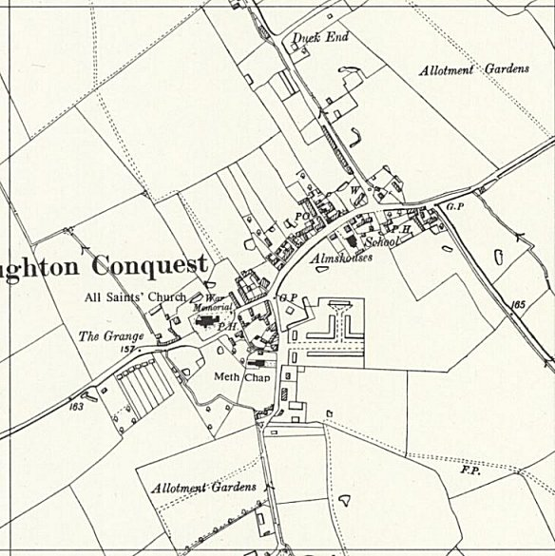
 | Ordnance Survey 1960

