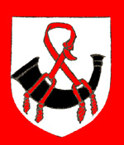
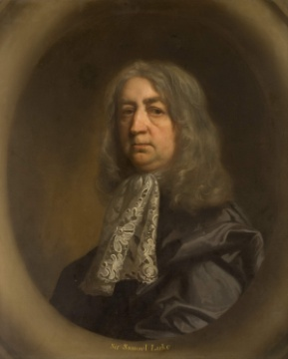
Sir Samuel Luke
Samuel Luke was born 21 March 1603 and baptised at six days old in Southill, Bedfordshire. He was the son of Sir Oliver Luke MP and his wife, Elizabeth was daughter and coheir of Sir Valentine Knightley of Fawsley, Northants.
Sir Samuel’s great-grandfather was Sir Walter Luke, Justice of the King's Bench, who married Anne Launcelayn, nurse to King Henry VIII. Sir Walter died in 1544 and his son Nicholas, a Baron of the Exchequer, succeeded him. The family were prominent in the area, with Sir Oliver Luke being Member of Parliament for Bedfordshire from 1614 to 1648.
Samuel attended Eton from 1617 to 1619 and travelled abroad in 1623. He was married on 2 February 1624 to Elizabeth, daughter of William Freeman (London haberdasher & merchant) and was knighted on 20 July of the same year. They had five children: Samuel (d. 1639; Martha (d. 1673); Sarah (d. 1690); Jane (d. 1710) & Oliver (1626-1708).
In April 1640, he was elected Member of Parliament for Bedford in the Short Parliament and was re-elected for the Long Parliament in November 1640. In the latter election, Samuel, a rigid Presbyterian, is known to have had the support of much of John Bunyan's future congregation.
During the English Civil War, Luke was governor of the Parliamentary outpost garrison in Newport Pagnell, Buckinghamshire, from late 1642 until June 1644. It was there that John Bunyan served as a conscripted soldier. During the war, as scoutmaster-general to the Earl of Essex, Luke achieved distinction for his diligence and skill in espionage.
He subscribed to the Solemn League and Covenant and in 1648, as one of the tellers for the treaty of Newport, he was imprisoned for a few days after Pride’s Purge, and ‘refused all public employment ever since till the sitting of the secluded Members’. He was returned as member for Bedford in 1650.
On the death of his father in 1651, Samuel inherited the family estate. He lived at Woodend Manor (formerly Launcelayn's Manor), which stood on the west of Northill Road and just north of Water End Road.
In April 1660, he was re-elected MP for Bedford in the Convention Parliament but lost his seat in 1661 and was obliged to alienate Hawnes, one of his principal estates, to Sir George Carteret.
Luke died and was buried at All Saints church, Cople on 30 August 1670. He was the last of the family to sit in Parliament. His wife Elizabeth died in 1694 and was also buried at Cople.

In 1684, Luke was identified with the principal character in Samuel Butler’s Hudibras, a satirical poem about the Civil War.

In 1686, Woodend Manor was sold to Sir William Gostwick of Willington. His grandson - William -sold Woodend Manor in 1731 to Sarah, Duchess of Marlborough, who sold it in 1779 to the Duke of Bedford. In 1902 it was sold to George and James Keeble of Peterborough. The manorial estate was quickly broken up, with Colonel Frank Shuttleworth of Old Warden being the principal landowner. A succession of Law of Property Acts, in the 1920s, abolished manorial fines and incidents, as well as copyhold land tenure, thus abolishing manors in practically all but name. Woodend Manor house was pulled down and Cople House built on the site. Cople House burnt down in 1971 and the site is now a housing estate called Woodlands Close.

