The Elstow Pillbox

The only remaining 2nd World War Army pillbox in Bedford is located in the Interchange Retail Park, yards from Costa coffee and the M&S food-hall.

In October 2016, Elstow resident Jon Miles was with Denis Carr, an Elstow Parish Councillor, looking for byways, paths and bridle ways that have always been used but which are not listed anywhere. They were doing this because if these paths are not listed by 2020 on the local Council records, then they would be lost and could be built on by developers.

On one of their walks, they discovered an overgrown brick building that they recognised as being a World War Two pillbox.

When the German Army invaded Poland in 1939, they started the 2nd World War. They then swept into Europe - invading Czechoslovakia, Norway, Denmark, Holland, Belgium and France. Britain stood totally alone, with the only help coming from their Commonwealth partners - no other country. It was thought that Germany would invade this country by 1942, so thousands of these pillboxes’s - so called because of their shape - were built to protect important war sites - in the case of Elstow, the railway and the Elstow munitions factory. (Run by the Joe Lyons catering group!)

There was another pillbox in Ampthill Road and one in Kempston Hardwick.

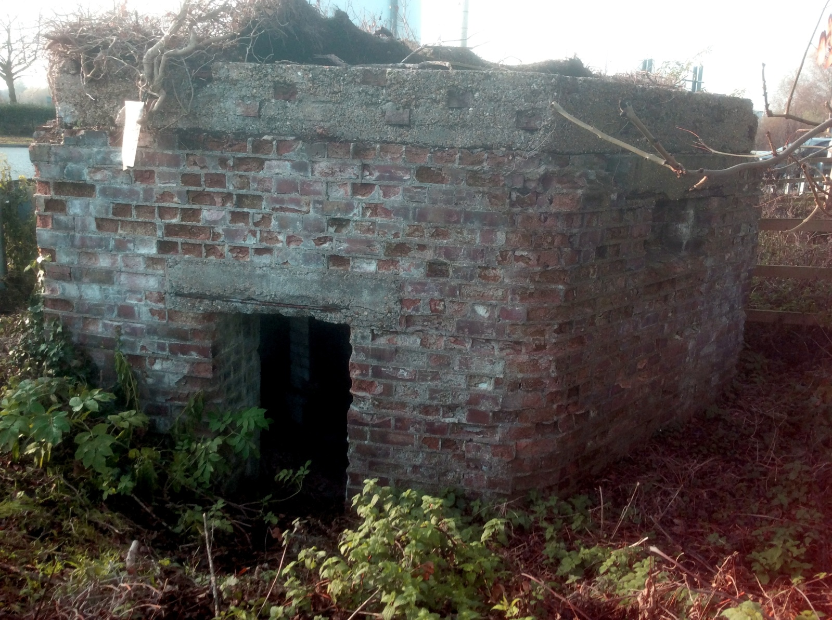
The Elstow Pillbox - Before restoration

Jon decided that, this being the only remaining pillbox in the area, it should be preserved. He spent a long time trying to raise money and asked English Heritage, British Legion, the Harpur Trust, Bedford Borough Council but all rejected his request. Eventually, Elstow Parish Council agreed to a grant of £1000, Borough Councillor Tim Hill offered £1000 from his Ward Fund and then the Gale Family Trust offered £1600. This reached the total that Jon had been quoted by builder Pelham Chambers, who has done lots of work for Elstow Parish Council to a good standard. The Gale Family Trust also agreed to the pay £515 for a lectern style information board. And Dr Michael Osborne donated £100 to the project.

Jon became the project manager and spent a lot of time getting rid of 20 years of weeds and vines, some of which had gotten into the brickwork and had to be dug out at ground level. And, of course, when Pelham got into the job of restoration he and Jon soon realised it was a far bigger job than had first been assumed.

The first three courses of bricks under the roof had to be removed, as they were disintegrating, almost to dust. The reinforcing rods crumbled to the touch but then the whole structure was 76 years old and had totally open to the elements for all of those years.
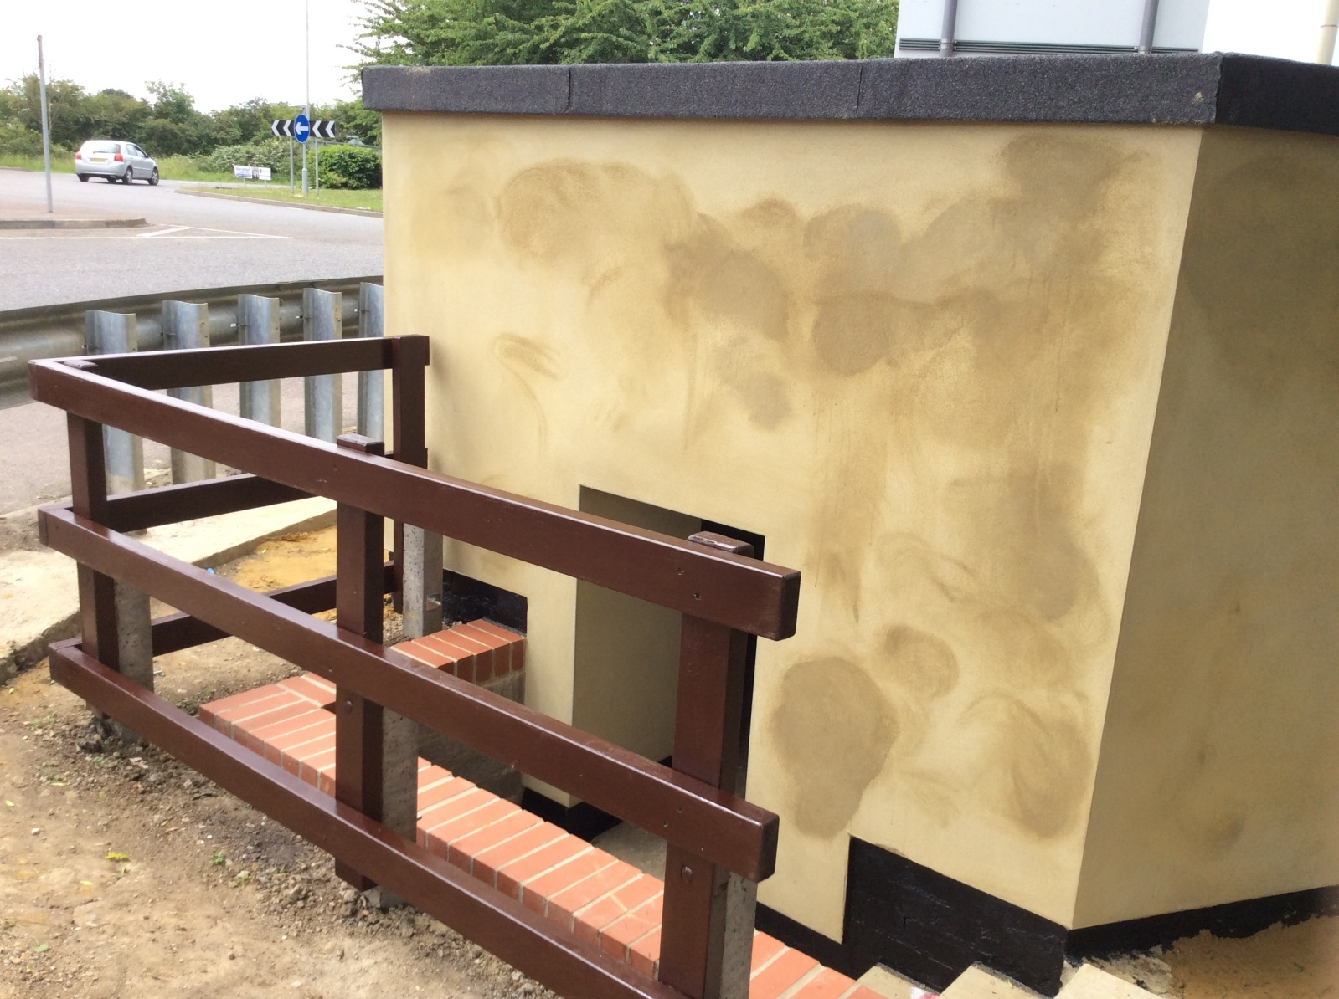
The Elstow Pillbox - After restoration

The roof was a solid chunk of concrete so was thought to be, probably, okay but it was decided that a heat-sealed roof covering would be desirable to protect the slab and the building from the elements. Pelham knew the roofing contractor Malcolm Hendrickson and said he was good guy so Jon went to talk to him. Malcolm agreed to put on the roof covering at no charge - if he had charged, it would have cost about £1200.
The outside walls were then covered with a cement screed, again to protect the brickwork. Jon decided it needed painting with anti-graffiti paint, to protect it from vandals and to blend in better with its location. Pelham began painting it (on Wednesday 20th June 2018) a dark gray/green colour.

When it was built in 1942 there was less soil all around the building, so it was possible for members of the Home Guard to just walk in. However, now the door is a lot lower due to all the soil that has gathered around the building over the past 70 odd years. So steps and a railing have been added.

The inside has not been altered but has its original whitewash finish.

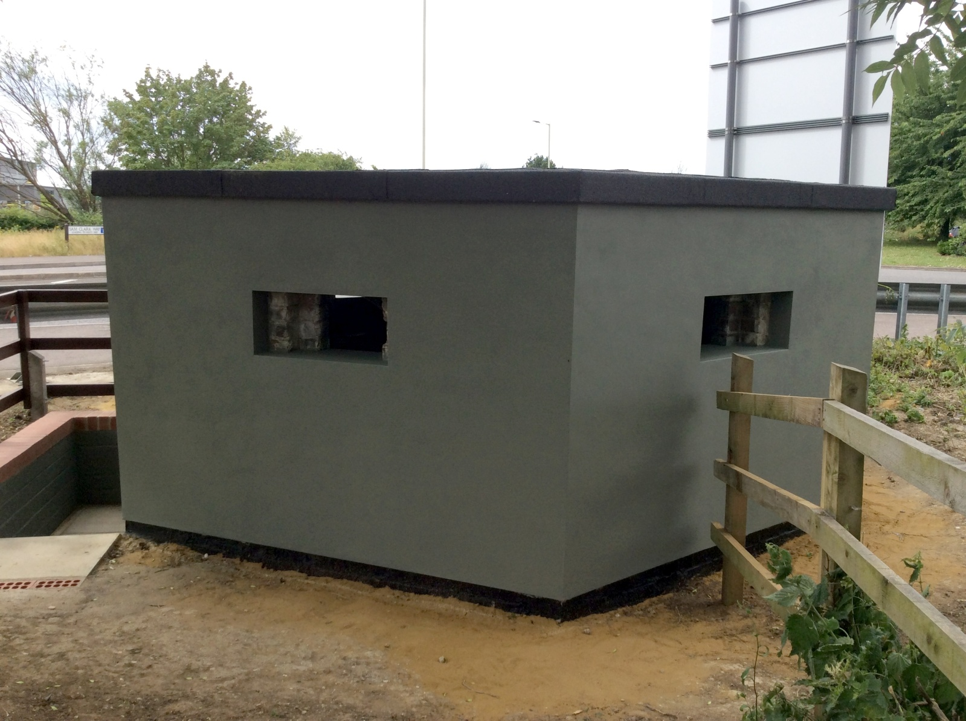

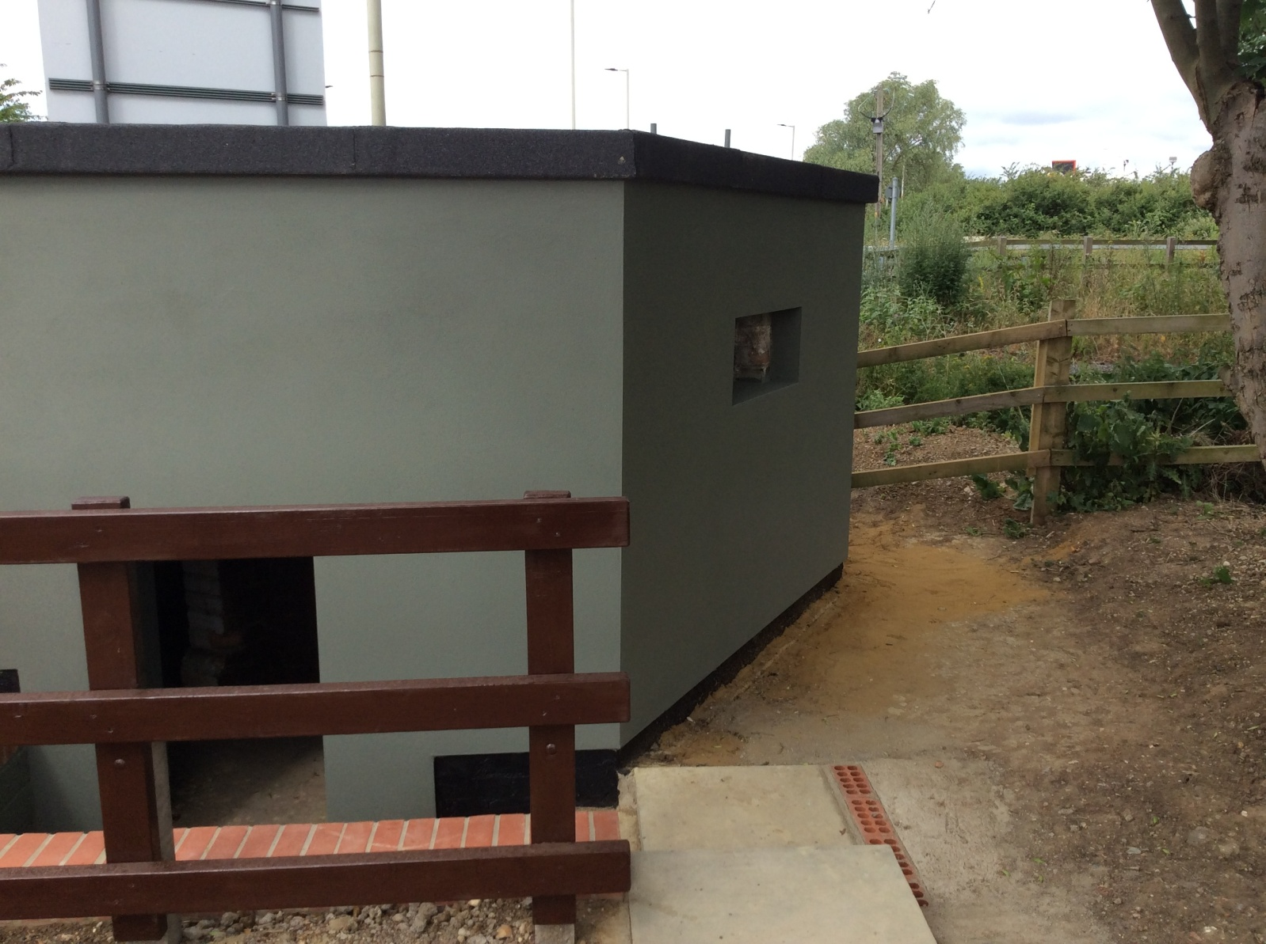

People can go in as long as they are careful - they do not have to book but if they contact Jon, he can arrange to be there and explain what the pillbox was for, why it is where it is and for safety.

In August, once the interpretation board has been made, there will be an official opening.

Jon Miles, Bunyan’s Mead, Elstow.
Email; jon.miles2017@gmail.com
Mobile; 07709 879 245

Jon wishes to thank the sponsors of this project, who had the vision to understand what was involved and for saving a small part of our heritage:

The Gale Family Trust
Elstow Parish Council
Tim Hill - Liberal Democrat Councillor for Stewartby.
Pelham Chambers - who undertook the restoration, work.
Malcolm Hendrickson - roofing contractor.
Dr Michael Osborne - author of 20th Century Defence of Britain.

